Brownhill Learning Community supports the ethos of the United Nations convention on the rights of the child in all aspects of education provision and is working towards the rights, respecting school award.

BEHAVIOUR

POLICY

Date Reviewed | Reviewed by | Next Review Date
August 2022 | Laura Coe | July 2023
June 2023 | Laura Coe | June 2024

OBJECTIVES OF THE POLICY

Provide clarity and guidance to stakeholders about the support and management of behaviour at Brownhill Learning Community.

PRINCIPLES

Through a calm, caring, positive, fair and firm approach Brownhill Learning Community aims to:

Encourage positive behaviour through the use of celebrating success, praise and rewards.

Discourage inappropriate behaviour through the use of a tiered and structured behaviour system and using appropriate consequences consistently throughout school.

Raise our pupil's self-esteem, independence and increase levels of self-responsibility through group and individual target setting and sharing those targets with pupils and staff for a holistic approach on each individual.

At Brownhill Learning Community we aim to have a positive ethos celebrating both behavioural and academic achievement. We aim to provide an engaging curriculum that is tailored to the individual needs and learning styles of each student.
Appropriate acceptable behaviour is taught though planned offsite activities (social & communication), modelling and de-brief after incidents and utilising class charts as a tracking system for pupils, parents and staff on each pupils behaviour on a daily, weekly and termly basis.

ROLES AND RESPONSIBILITIES

The promotion of positive behaviour is the responsibility of the school community as a whole.

The Governing Body, Head teacher and Staff are responsible for ensuring that all aspects of the school’s Behaviour Policy and its application promote equality for all pupils.

The roles include:

- The Governing Body supporting and promoting the principles underlying the school’s Behaviour Policy.
- The Head teacher and Leadership Team in framing and establishing an environment that encourage positive behaviour and regular attendance to include appropriate curriculum, formal conferencing.
- All staff in ensuring that the policy is consistently and fairly applied and that pupils are supported in behaviour for learning.
- Pupils who are able to, behave in a way that promotes the learning of all in the community.
- Parents and carers in taking responsibility for their child’s behaviour inside and outside the school to maintain high standards of behaviour.

REWARDS

Pupils can earn rewards on a weekly, half termly and yearly basis, we will track every student's behaviour on class charts where pupils earn 4 points per lesson based on; individual target, EHCP target, expected behaviour and expected work (linked to EHCP). Behaviour is reviewed in each lesson along with form time at the beginning and end of each day.

See Appendix 3 Rewards/Class Charts - pupils can earn virtual money each week which they can choose to spend throughout the year or save up, along with half termly and termly behaviour and attendance bonus money.

Virtual Money values (weekly)

- >95% = £5
- 94>90% = £3
- <80% = £1

Praise is a powerful motivator, we aim to ensure praise is plentiful whilst being earned and given genuinely. Celebration assemblies provide the opportunity for pupils to be publicly praised, these take place on a weekly basis celebrating pupils with 100% behaviour and the most improved form group.

CONSEQUENCES

The system of consequences is consistent across the school with all pupils follow a tiered process linking to Brownhill Learning Community’s classroom and school expectations (Appendix 2). If a pupil is not following expected behaviour however (not stopping others from learning), they are in a Tier 1- affecting their class points and catching up on work at break times. If a pupils inappropriate behaviour continues and disrupts others learning they are then put on a Tier 2- resulting in a pupil being asked to go to have support from the site HLTA/SLT along with points being affected and catching up with work in their break times or after school and a possible phone call home if behaviour continues. If behaviour escalates to bullying, racism, sexualised comments, verbal abuse/threats to peers or staff and damage to property then a pupils will be put on a Tier 3- to which the pupil will have immediate removal from class from SLT or pastoral support and consequences will be decided dependent on the severity of a pupils actions (Appendix 4).

SUSPENSIONS

Suspension from school is considered an absolute last resort. Only the Head teacher and Deputy Head teacher have the authority to suspend a pupil. The Head teacher/Deputy will inform parents/carers of the decision to suspend and work may need to be set by teachers for completion by the pupil whilst suspended. On return from suspension the pupil, with their parent/carer, will meet with a member of SLT for a reintegration meeting. During this meeting the incident will be discussed and expectations of behaviour explained to the pupil and their parent/carer and additional support to be agreed where required.

POSITIVE HANDLING

In routine circumstances staff should refrain from positively handling; however, it is important that staff are fully aware of the legislation and guidance provided by the DCSF/DfE with regard to the circumstances when positively handling pupils could be used by a member of staff, what is acceptable, and what a member of staff should consider before they intervene in a particular situation. As part and parcel of this, staff need to be aware of and act in accordance with any Positive Handling Plans (described within the Behaviour Plans) for individual pupils – these documents can be found on Behaviour Smart.

It is important that staff should ensure that they have exhausted all other strategies and are confident they could justify and explain their use of physical intervention before making a physical intervention. In short, it is the final option and should be avoided unless there is no other reasonable alternative open. When using physical intervention all staff go by reasonable, proportionate and necessary. Some of our pupils may need to have written for them a specific risk assessment. This will be completed in conjunction with all parties and must be signed by parents/carers, pupils and staff. It must be shared with all staff who need to be aware of any associated risks. Staff will undertake dynamic risk assessments as part of their day to day behaviour management strategies and this dynamic risk assessment will encompass any necessary requirement for positive handling.

Detailed guidance regarding the Use of Reasonable Force is to be found in the school’s Positive Handling Policy. All staff are Team Teach Trained as soon as possible after appointment.

POST INCIDENT PROCEDURES

After any incident a de-brief session must take place. This should be done sensitively once everyone involved has recovered, staff supporting the de-brief do not necessarily need to have been involved in the incident. Team Teach procedures are followed and any resulting changes to the Behaviour Plan must be communicated to all staff. All associated paperwork must be completed and any handling incidents must be reported onto Behaviour Smart and CPOMS.

RESPONSES TO SPECIFIC BEHAVIOURS

Whilst some flexibility is anticipated when supporting and managing much behaviour, other behaviour must be managed consistently across the school.

These are:

Smoking: The member of staff who sees a pupil of smoking/vaping should inform their class/form tutor, the pupil will be expected to hand over any cigarettes, e-cigs, tobacco and lighters/matches. The class/form tutor will then inform a member of SLT and a pupil will be issued an appropriate consequence usually an after school stop-back and a phone call home. Persistent smoking inside any Brownhill Learning Community building must be treated seriously and the Head teacher/Deputy will determine an appropriate sanction for this.

Absconding: If a pupil absconds from the school site the school office and SLT must be informed immediately. The response then depends on the age and development of the pupil. A member of staff should attempt to keep the pupil in sight without pursuing them and ensure the member of staff is contactable by mobile phone. As a general rule if a pupil is out of sight for 10 minutes the parent/carer and sometimes police are called and informed; this time scale could be reduced significantly if the pupil is young or vulnerable. A logical consequence for this behaviour would be to make up any work missed with appropriate support once it has been ascertained why the pupil left the site.

Bullying: Any incident of bullying, including cyber-bullying, is taken extremely seriously and will be investigated by SLT. (Refer to Anti-Bullying policy).

Assault of a peer or member of staff: Assault of any person is always unacceptable. Those assaulted will always be offered first aid and support. The Head teacher, through discussion with SLT and other staff, will then decide if further consequences, for example suspension or police involvement, are necessary.

Drug use: any concerns and suspicions about drug misuse possession or a person being under the influence of drugs must be reported to the Head teacher/SLT who will then decide if further consequences, for example exclusion or police involvement, are necessary. A child protection referral should also be made at this point via CPOMS. Any pupil who arrives at school and is suspected of being under the influence of a substance needs careful monitoring and parents/carers informed. We cannot simply blanket refuse to admit such pupils to school however if pupils are deemed to be a health and safety risk (by SLT only) then parents/carers should be called to collect from the premises. Again, a Child Protection referral must be made at this point so that pupils can obtain relevant support from other professionals.

Significant damage to property: A pupil who causes intentional and significant damage to property will be issued with a bill of damages sent to their parent/carer or an amount (to be determined by the Head teacher or Deputy) taken out of a pupils ‘virtual money’ and an after school stop-back.

Sexism and sexual harassment: Sexism and sexual harassment will not be tolerated at Brownhill Learning Community and will be immediately investigated by SLT with relevant interventions needed. If sexist comments are made by pupils’ staff will call out pupils who are using this language, ensure their understanding and take relevant restorative conversations where necessary.

SUPPORT SYSTEMS FOR STAFF

All staff have a responsibility to deal with incidents of misbehaviour when it occurs, respond accordingly and where appropriate - possibly in conjunction with a ‘fielding’ colleague - record the incident and the follow-up action on the school’s behaviour tracking system (Behaviour Smart and CPOMS).

Incidents of a more serious nature should be discussed at debrief and may be referred to the Welfare Team and SLT.
Staff who have repeated difficulties with a particular individual or teaching group should seek initial support and guidance from the site SLT and HLTA’s.

If misbehaviour is so serious that teaching and learning cannot continue, staff should use the mechanisms in place (send LSA or pupil) to summon additional support. It is important that staff follow up the exiting of a pupil from their lesson and attempt to ensure the situation is not repeated in their next lesson through means consistent with the School’s behaviour policy (including appropriate use of thought-out sanctions).

Likewise, staff need to be familiar with the School’s protocols and scripts for a ‘managed return’ to class so that the risk of an unsuccessful return is minimised after the initial incident has been dealt with elsewhere by colleagues. The overarching aim should be to talk through the issues with respect and to rebuild and repair the relationship. As adults, we should always ask ourselves if we have given the child every opportunity to put things right and to ensure that there is a way back into the classroom at every possible point.

CONFISCATION

All staff should consider the following criteria when deciding whether to confiscate an item from a pupil, pupils have one warning to put an item away and then it is confiscated from them:

- An item poses a threat to others: for example, a laser pen is being used to distract and possibly harm other pupils or staff;
- An item poses a threat to good order for learning: for example, a pupil uses a personal music-player during lesson time;
- An item is against school uniform rules: for example, a pupil refuses to take off an outdoor coat on entering a classroom;
- An item poses a health or safety threat: for example, a pupil wearing large ornate rings in PE may present a safety threat to other pupils;
- An item which is counter to the ethos of the school: for example, material which might cause tension between one community and another;
- An item which is illegal for a child to have: for example, racist or pornographic material. Protocols for how to deal with such items can be agreed with local police.

All belongings will be handed in at the beginning of the day as agreed with parents and carers during the admission process. This should ensure that confiscation of belongings rarely occurs. However, there may be some instances where pupils do conceal items on their person (vapes, mobile phones etc.).

These will be dealt with in the following way:

Mobile phones – in the first instance, a pupil will be simply asked to handover the item and a reminder will be made that mobile phones are not permitted. The phone will be handed in and the pupil will be checked more thoroughly as part of the next day’s morning routine. No official sanction is needed at this point.
However, if a pupil persistently conceals a mobile phone on their person then a sanction (stop-back) is needed alongside a phone call to parents/carers. We should not be stopping pupils from having their phones returned to them at the end of the day as this could lead to a reduction in their safety should a problem arise on the way home but repeated incidents of this nature may lead to parents/carers being called into school to discuss the issue.
Vapes/e-cigarettes – during the admission process, all parents/carers are asked if their children smoke vapes/cigarettes. This is also followed up with an offer of smoking cessation sessions with the school nurse to support pupils with an existing nicotine habit.

If pupils of secondary age hand over their belongings willingly at the start of the day, these may be returned to them at the end of the school session. However, if pupils are caught smoking during the school day, the items will be confiscated and destroyed. Parents/carers must be informed and the relevant SLT on site to make a decision as to the appropriate sanction required (stop-back).

Any illegal substances or paraphernalia MUST NOT IN ANY CIRCUMSTANCES be returned to a pupil. These should be confiscated, parents/carers, SLT and the Welfare Team informed.
---------------------------------------------------------------------

APPENDICES:

APPENDIX 1 - Example reflection sheet
APPENDIX 2 - Examples of Classroom Expectations / THINK…
APPENDIX 3 - Rewards
APPENDIX 4 - Behaviour tiers
APPENDIX 1: Reflection Sheet

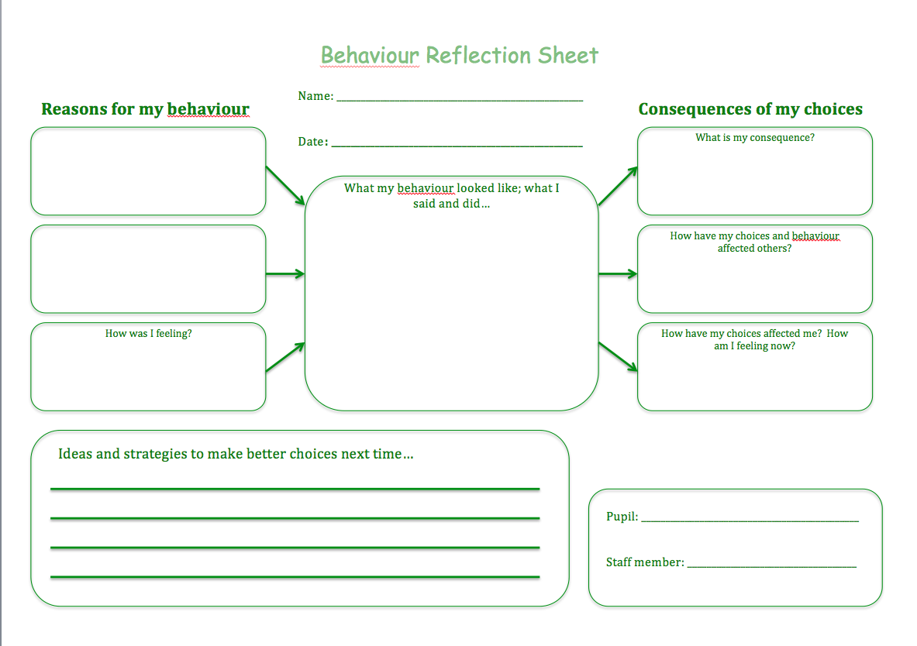

APPENDIX 2: Classroom Expectations

1. Compassion and Respect for Everyone (CARE)
2. Appropriate language at all times
3. Appropriate uniform should be worn
4. Follow instructions
5. Complete work to best of ability

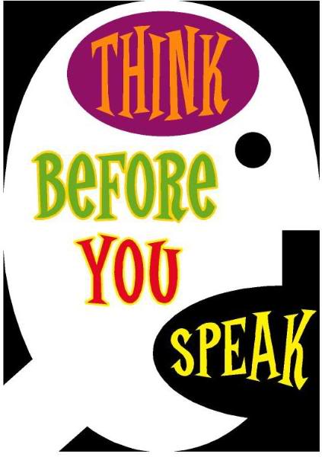

THINK

Is it Truthful?
Is it Helpful?
Is it Inspirational?
Is it Newsworthy?
Is it Kind?

Before you open your mouth and say anything,
Ask yourself...
If the answer is no…
….. keep quiet!

APPENDIX 3 - Rewards
From September 2022, we will be using Class Charts, an interactive software system to track in class behaviour and progress towards targets. This will then inform our new reward system.

It is imperative that this system is used properly by everyone to maximise effectiveness. The interface is really straightforward.

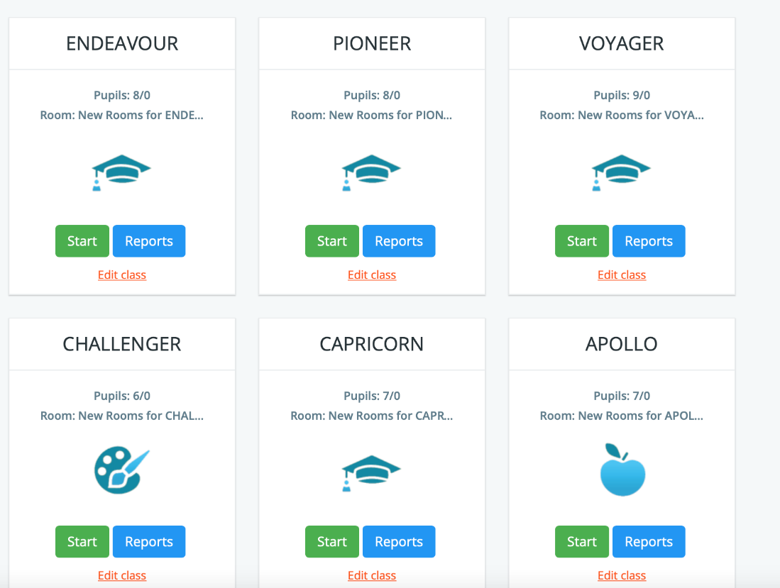

All classes, pupil and behaviour targets will be already prepopulated.

In each class, pupils can receive 4 points-either green (positive) or red (negative) dependent on the choices they have made- in this way we move towards pupils taking responsibility for their own behaviour and understanding the consequences of this.

The aim is that as pupils move through the school, they move towards self-regulation.

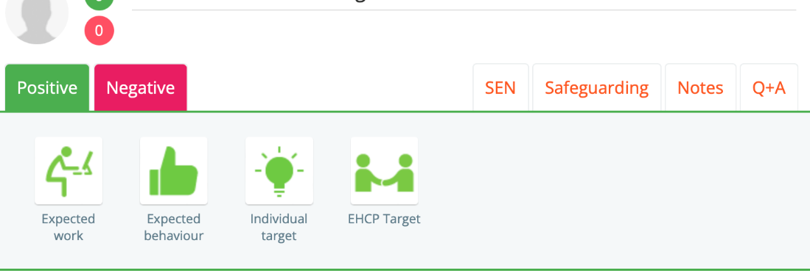

Points are given for:

- Work- all work completed to an appropriate standard
- Behaviour- behaved appropriately in the lesson
- Individual target- for example use appropriate language with only 1 reminder
- EHCP target- bespoke to each child (if not an EHCP learner then a group target should be used here)

Points must be awarded at the end of every lesson as part of plenary- the most effective way is to have it up on the whiteboard and ask pupils what points they think they should get so that they have ownership of their behaviour.
For younger pupils, there is a great deal of power in getting them to come up and press the buttons themselves as part of the discussion.

Every child can achieve 28 points in a day. On a Thursday evening, the percentages will be totted up by HLTA’s for each site. And put onto this spreadsheet.

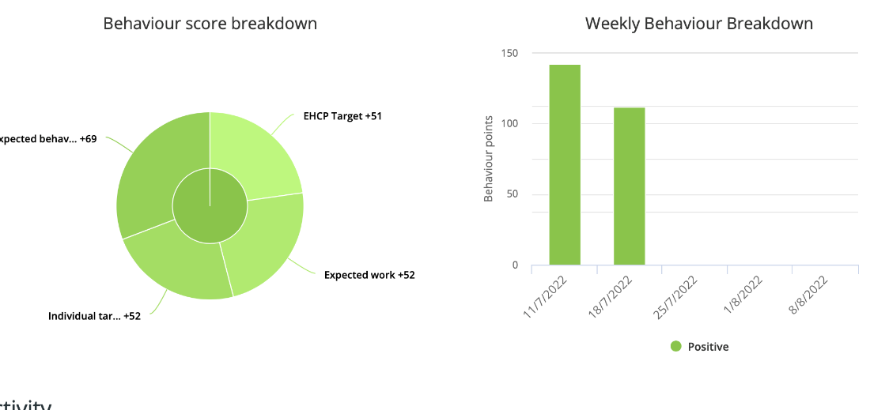

An email will be sent out to each site entitled “Scores on the doors” letting you know the scores for each pupil and the average for each class. On a Friday, the best performing class gets a treat- chocs, biscuits etc. to share (group reward) and anyone on 100% is put into a draw for a bar of chocolate (individual reward).

Points mean prizes!!

We will be using a system of Virtual Money so:

Weekly Points

- 95-100%=£5
- 90-94%=£3
- 85-89%=£1

Termly Bonuses

- 95%+ each week=£10
- Attendance over 95% for the term=£10
Spending Points

2 weeks before the end of every half term, HLTA’s will ask form tutors for a list of what their pupils want to spend their virtual money on e.g.- JD vouchers, Amazon, XBOX etc. and these will then be purchased.

Younger pupils may want toys etc. from Argos/Amazon. In this way, pupils will receive meaningful rewards bespoke to them.

The points are linked to high expectations of work and behaviour. Pupils can choose to save their money if they wish.

If there is damage done by an individual, school will take a nominal amount of virtual money as recompense from the student in order to reiterate the idea of personal consequence.

Using the system to its full effect

- Use as part of behaviour management- “Remember your points, “This is a warning that you’re heading for a red point..” Let’s try and stay on green shall we?” etc.
- Praise when awarding green points and encouragement when awarding red points- ‘it was just a blip, let’s try for full greens next lesson”
- Use classroom display to track money then it’s a visual reminder
- Celebrate 100% pupils and best performing classes publicly in assemblies etc.
- Take time out to praise pupils not in your class to help build a positive community.
- Encourage parents to sign up to the app so they can reinforce at home

APPENDIX 4 – Tiered Behaviour System

EXPECTED BEHAVIOUR  Coats and hats off.  Belongings given in.  Follow all instructions.  On task.  Speak appropriately to peers and staff.  Follow ‘Classroom Expectations’  STAFF ACTIONS  Praise (public or private)  Positive phone call home  Class Charts points awarded | TIER 1  Refusal to follow expected behaviour but not stopping the learning of others.  e.g.- Talking, conversational swearing, work avoidance.  STAFF ACTIONS  Use of reminders and warnings of expectations and consequences.  Use of de-escalation.  Support from LSA.  Red points given.  IF SUCCESSFUL- Pupil praised for making the right choice.  IF UNSUCCESSFUL- Break time catch up with teacher. | TIER 2  Persistent refusal to follow behaviour expectations, disrupting the learning of others.  e.g. - Walking out of class without permission, verbal abuse to staff or peers.  STAFF ACTIONS  De-escalation, directed time-out with class LSA, work in another room.  Red points given.  IF SUCCESSFUL- Pupil re-integrated into class.  IF SUCCESSFUL- Lunch time catch up with teacher.  Phone call home. | TIER 3  Bullying, racism, sexualised language, verbal abuse/threatening behaviour to peers or staff, damage to property, assault.  STAFF ACTIONS  Immediate removal from class.  Referral to SLT.  CONSEQUENCES-  After school catch up.  Internal exclusion 1:1  Fixed term exclusion followed by parent meeting.  Phased return into school.  Removal of Virtual money for damage.  NB- A restorative meeting with staff/ peers affected may be used at any tier.

